|  |  |  |  |
| --- | --- | --- | --- |
|  | Bansilal Ramnath Agarwal Charitable Trust's  Vishwakarma Institute of Information Technology  **Department of**  **Artificial Intelligence and Data Science** | | |
| Name: Siddhesh Dilip Khairnar | | | |
| Class: SY | Division: B | | Roll No: 272028 |
| Semester: IV | | Academic Year: 2022-2023 | |
| Subject Name & Code: ES22201AD: Probability and Statistics | | | |
| Title of Assignment: Perform mean, mode, median for the given dataset | | | |
| Date of Performance: 03-04-2023 | | Date of Submission: 10-04-2023 | |

**ASSIGNMENT NO. 5**

**Background information:**

1. Calculate the mean: To calculate the mean, simply add up all the numbers in the dataset and divide by the total number of values. In R, you can use the mean () function to do this.
2. Calculate the mode: To calculate the mode, you need to find the value that occurs most frequently in the dataset. In R, you can use the Mode () function from the DescTools package to find the mode.
3. Calculate the median: To calculate the median, you need to find the middle value in the dataset when it is ordered from smallest to largest. In R, you can use the median () function to do this.

**Program and Output:**

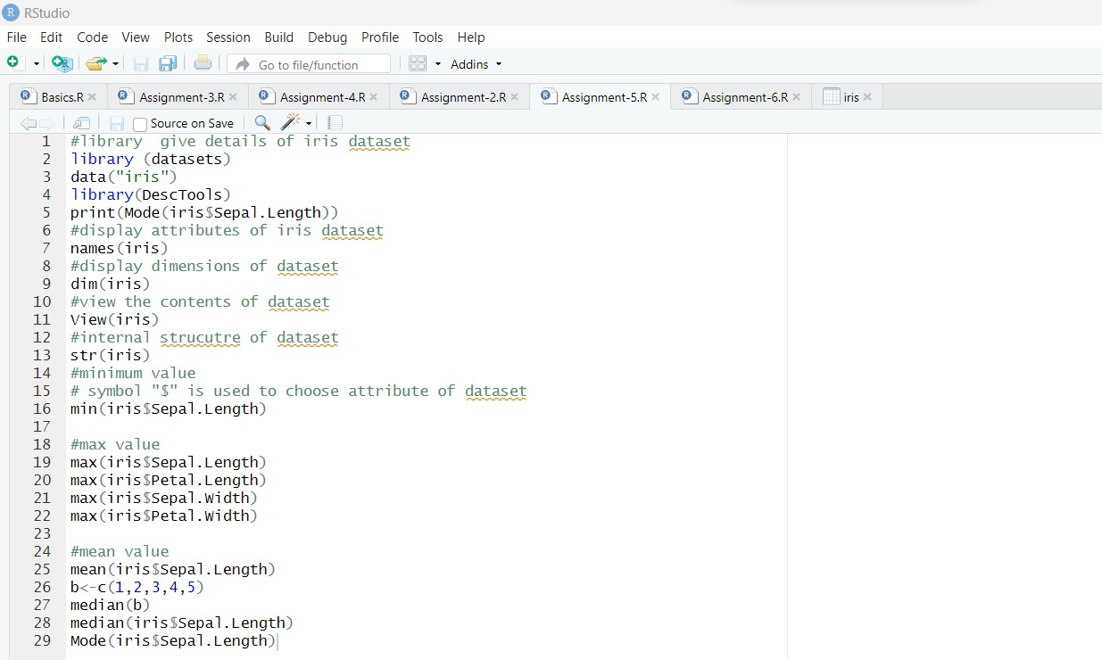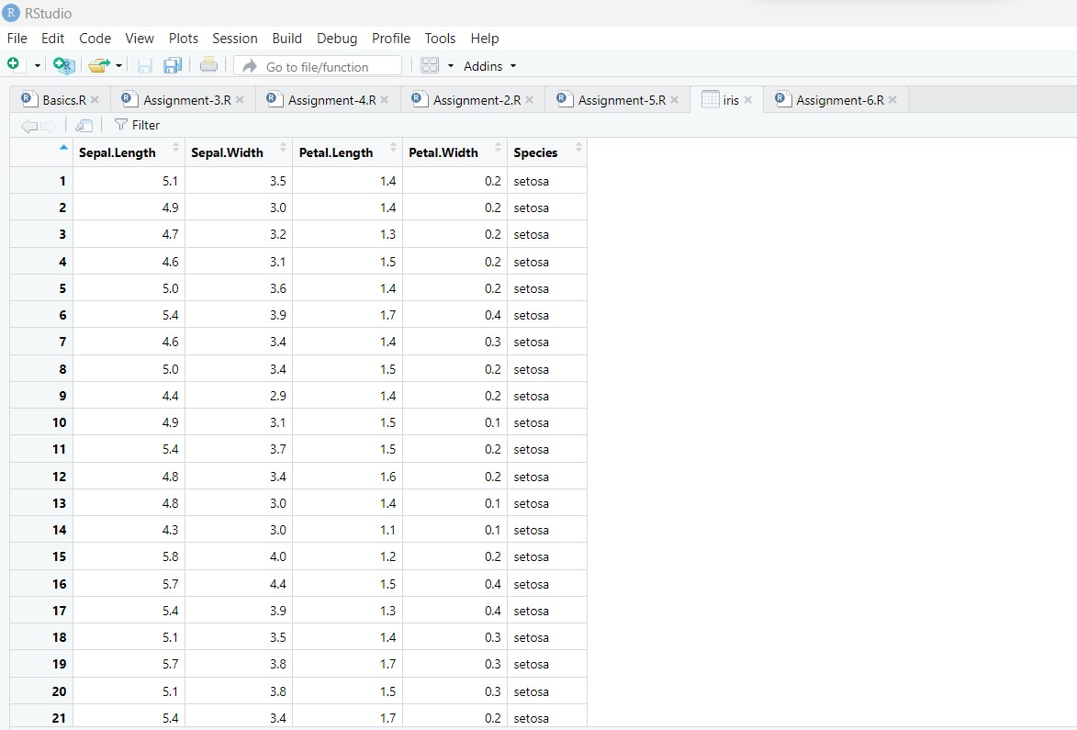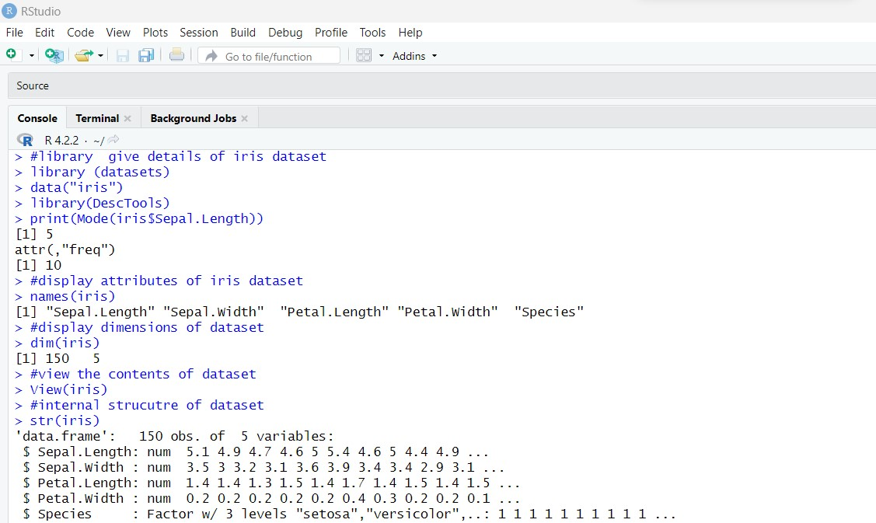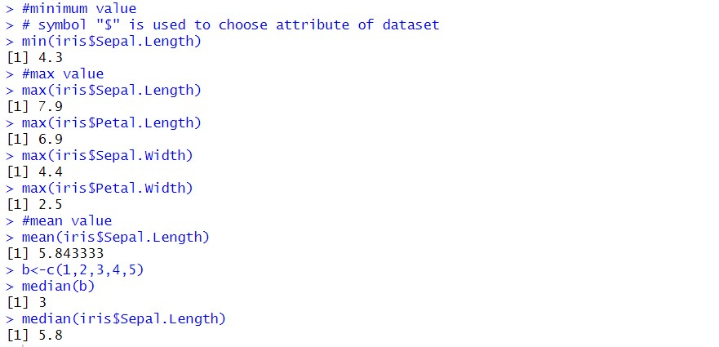

**Conclusion:** Thus, we have executed an R script to demonstrate the mean, mode, and median operations on a dataset processed using various pre-processing functions.